AI Traffic Moderator
*Note: Sub-titles are not captured in Xplore and should not be used

Poorva Chougule
Dept. of Computer Engineering
Marathwada Mitra Mandal’s College of Engineering Pune, India
poorvachougule2023.comp@mmcoe.edu.in

Niel Mandhare
Dept. of Computer Engineering
Marathwada Mitra Mandal’s College of Engineering Pune, India
nielmandharae2023.comp@mmcoe.edu.in
Tanushka Chavan
Dept. of Computer Engineering
Marathwada Mitra Mandal’s College of Engineering Pune, India
tanushkachavan2023.comp@mmcoe.edu.in

Mayuri Narkhede
Dept. of Computer Engineering
Marathwada Mitra Mandal’s College of Engineering Pune, India
mayurinarkhede@mmcoe.edu.in

Manaswin Sripatnala
Dept. of Computer Engineering
Marathwada Mitra Mandal’s College of Engineering Pune, India
manaswinsripatnala2023.comp@mmcoe.edu.in

Abstract—Urban traffic, especially on single-lanes has become a severe challenge due to increase in the vehicle density and insufficient signal timings. Traditional signal system runs on fixed time cycles which leads to delays and road hindrance during peak hours. To handle this problem, this research paper presents an AI-driven real time traffic management system that dynamically changes the signal based on read time road conditions. The system relies on real-time video analysis, applying the YOLO algorithm for fast and precise object detection. YOLO integrated with python uses live camera feed to detect and count the number of vehicles frame by frame. Depending on the count of vehicles and traffic density the signals are adjusted dynamically.
Keywords—AI-based Traffic Management, Real-time Signal Control, YOLO Object Detection, Vehicle Density Analysis, Dynamic Traffic Signal System.

Introduction
Congestion of traffic on roads is one of the major problems faced in modern cities, especially on narrow and single-lane roads. These roads are common in residential areas, around schools, or inside campuses, and due to poor traffic flow, they often become blocked which causes many issues. Traditional traffic lights work at fixed timing, they do not change according to the actual traffic on the road, instead they have fixed times. As a result, vehicles may wait even when the road is clear or get stuck in long queues during heavy traffic. This leads to time loss, increased air pollution, and frustration for drivers.
However, most of the existing solutions are designed for large multi-lane intersections. They also depend on advanced hardware, cloud services, or complex machine learning techniques, which can be expensive and difficult to install or maintain.
Our project focuses on a simpler and more affordable solution, especially for single-lane roads, where the traffic conditions are different and often overlooked. We propose a system that includes:
YOLO-based vehicle detection, specifically tuned for small roads. A Python and OpenCV-based video processing system that analyzes live camera feeds.
A smart traffic signal logic that turns the light green when traffic gets dense and follows normal timing when traffic is low. The system uses external cameras to capture live traffic video, which is then processed locally on standard computing devices using Python and YOLO.
Compared to large-scale traffic control solutions, our approach remains relatively simple, affordable, and easy to implement, making it suitable for urban areas with limited resources or infrastructure. It addresses the overlooked challenge of single-lane traffic using real-time image processing in a compact and scalable way.
According to “Road Accident in India Report” by Ministry of Road Transport and Highway [*], the number of fatalities in India from 2018 to 2022.Fatalities slightly increased from 2018 to 2019, then dropped sharply in 2020—likely due to COVID-19 lockdowns. From 2020 onwards, the fatalities steadily increased, reaching the highest in 2022. Overall, the trend indicates a recovery and rise in fatalities after the 2020 dip. The accident severity in 2022, measured by deaths per 100 accidents across Indian states and UTs. Mizoram reported the highest severity (85 deaths per 100 accidents), followed by Bihar and Punjab. Kerala and Goa had the lowest severity, with less than 10 deaths per 100 accidents. The national average ("All India") accident severity stood at 36.5 deaths per 100 accidents. The number of road accidents decreased in 2020 across all road types but rose again by 2022, with "Other Roads" showing the highest accident rate. Similarly, fatalities dropped in 2020 and then increased again by 2022. This indicates a clear link between road type and both accident frequency and fatality severity.
Urban areas are facing severe traffic congestion due to the increasing number of vehicles. Traditional traffic management systems struggle to adapt to real-time conditions, leading to longer travel times, higher fuel consumption, and increased pollution. Additionally, emergency vehicles often face delays due to traffic signals which are not optimized.
In this study AI-Driven Traffic Management System aims to address these issues by monitoring real-time data. AI is used to optimize traffic flow, which can be integrated with Google Maps for dynamic route suggestions. This system can give priority to emergency vehicles through automatic traffic signal management.

Literature review

Ratan Bajaj [1] (2023), in “AI for Traffic Management,” studies machine learning models like Random Forest, Decision Trees, and SVM using traffic camera data. Random Forest performs best for predicting traffic flow and congestion, enabling real-time signal optimization. However, it lacks generalization across regions and depends on high-quality data.
Shruti Kanailal et al. [2] (2024), in “Smart Traffic Control System Using AI,” propose a YOLO-based system for real-time vehicle detection. It enables adaptive signals and “Green Corridor” support for emergency vehicles, reducing idling and emissions. However, it requires continuous data and has high setup and maintenance costs.
D. S. Shelar et al. [3] (2024) presents a YOLOv8-based traffic system that adjusts signals dynamically and prioritizes emergency vehicles. It improves flow and reduces congestion and fuel use but is costly and depends on reliable infrastructure.
Kushal Reddy and K. Shanthi Sree [4] (2024) use YOLOv3 for vehicle detection via live video. Their system adapts signals based on traffic density, improving flow, but requires high computation and camera infrastructure.
Farhan Sultana et al. [5] (2024) propose an AI-IoT traffic system for real-time monitoring and emergency detection. It enhances mobility and response time but needs strong infrastructure and high processing capability.
Nellore and Hancke [6] review wireless sensor networks for traffic monitoring, highlighting distributed sensing benefits but noting issues like scalability, energy use, and data reliability.
Genitha et al. [7] (2023) develop an ML-based signal control system that optimizes timing based on traffic density, improving flow and reducing wait time, though accuracy depends on data quality.
Nasim et al. [8] (2023) review AI techniques like computer vision and predictive analytics, emphasizing challenges such as data scarcity, infrastructure limits, and model reliability.
Chavan et al. [9] analyze intelligent traffic systems in India, identifying challenges like mixed traffic and weak infrastructure while stressing AI’s potential.
Balaji Ganesh and Appavu [10] (2015) propose a video surveillance system with big data analytics for traffic monitoring, improving decision-making but requiring high computational resources.
Agarwal et al. [11] discuss AI in intelligent transport systems, focusing on traffic prediction and automation, with challenges in cost, infrastructure, and integration.
Christofel Rio Goenawan [12] (2025) presents a system combining YOLOv5 and LSTM for detection and prediction, achieving high accuracy and reducing delays significantly. However, it requires strong computational resources and quality data.
Karthik et al. [13] (2022) proposes a CNN-based traffic system for vehicle detection and adaptive signals, improving accuracy and reducing congestion but needing high GPU support.
Zhang et al. [14] (2021) review reinforcement learning for traffic signals, showing improved waiting times and throughput, though limited by training complexity and data needs.
Kumar et al. [15] (2023) presents an IoT-AI hybrid system for real-time monitoring and congestion prediction. It improves efficiency and safety but depends on sensor reliability and infrastructure.

III. METHODOLOGY
The proposed system follows a pipeline-based architecture for real-time traffic signal control. The methodology encompasses five core modules: video acquisition, frame extraction, object detection, vehicle counting, and adaptive signal control. Figure 1 illustrates the skeletal functionality of the model and Figure 2 presents the system flowchart.

A. Video Input and Frame Extraction
The system acquires a continuous live video stream from a traffic surveillance camera positioned at an intersection. The incoming stream is decomposed into discrete sequential frames, each of which is independently processed for vehicle detection. This frame-level decomposition enables real-time analysis by reducing the computational complexity associated with processing continuous video data, ensuring low-latency response suitable for dynamic traffic environments.

B. Object Detection Using YOLO
Each extracted frame is passed through the YOLOv8 (You Only Look Once) object detection model, developed by Ultralytics. YOLO is a single-stage deep learning detector that performs bounding box regression and class prediction simultaneously in a single forward pass, making it well-suited for real-time applications. The model is pre-trained on the COCO dataset and configured to detect four vehicle categories: cars, motorcycles, buses, and trucks. Non-vehicle detections are filtered out to ensure that only traffic-relevant objects contribute to downstream processing.

C. Vehicle Counting Module
Following object detection, the system enumerates the total number of vehicles identified within each frame. This count serves as the primary quantitative metric for evaluating traffic density at the intersection. The vehicle count is continuously updated with each processed frame, providing a dynamic and accurate representation of real-time traffic conditions.

D. Adaptive Signal Control Logic
The signal decision module implements a threshold-based adaptive control strategy driven by the vehicle count obtained from the detection module. The control logic operates as follows:
- When the vehicle count exceeds 10, the signal transitions to GREEN, indicating high traffic density requiring immediate clearance.
- When the vehicle count falls between 5 and 10, the signal is set to YELLOW, representing moderate traffic density requiring caution.
- When the vehicle count is below 5, the signal remains RED, indicating low traffic density where flow is not warranted.
Each signal phase is governed by a timer-based cycle to prevent rapid state oscillation and ensure stable, predictable signal behaviour. This adaptive mechanism eliminates the inefficiencies of fixed-time signal controllers by dynamically responding to observed traffic conditions.

E. Real-Time Visualization and Monitoring
To facilitate system monitoring and performance analysis, the proposed system incorporates a real-time data visualization module. Vehicle count data is continuously plotted on a time-series graph, maintaining a rolling window of recent observations. This dashboard provides traffic operators with actionable insights into traffic flow trends, system responsiveness, and historical patterns within a session. The live annotated video feed is simultaneously rendered alongside the signal status, offering a comprehensive operational interface for traffic management personnel.

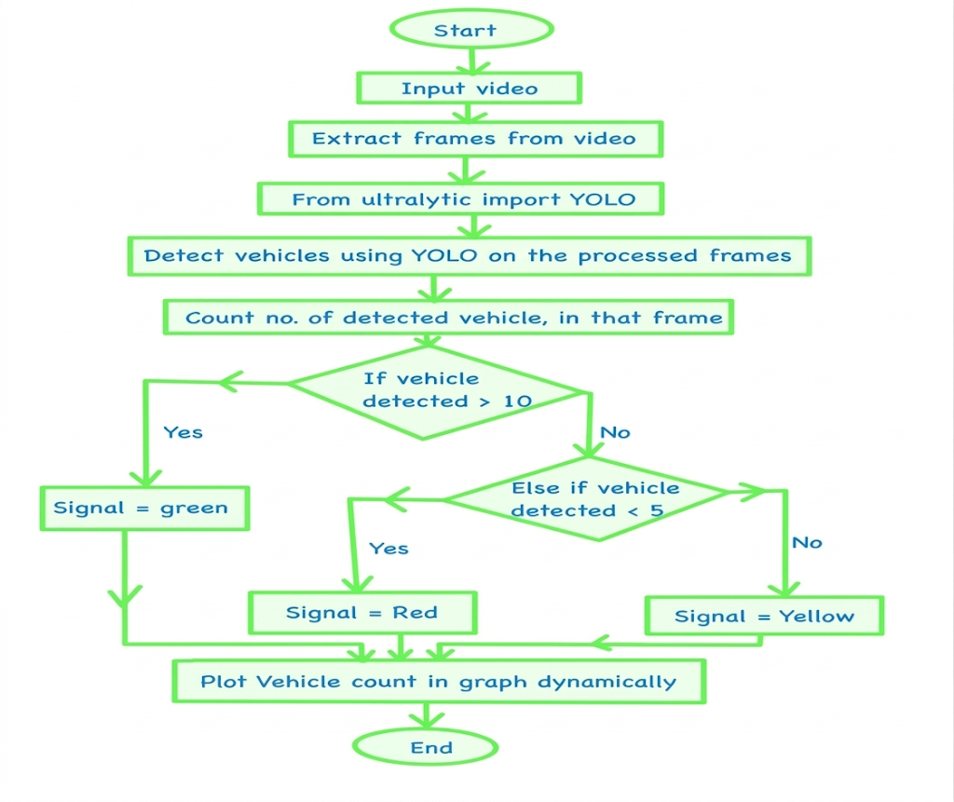
Fig. 1. Skeletal Functionality of model

IV. ALGORITHMS AND TECHNOLOGY
A. YOLO Object Detection Algorithm
The You Only Look Once (YOLO) algorithm serves as the core detection engine in the proposed system. Unlike traditional multi-stage detectors, YOLO performs object localization and classification in a single forward pass through the network, making it particularly suitable for real-time traffic monitoring applications. The algorithmic pipeline is described as follows:

1. Input and Preprocessing
The system accepts individual video frames as input images. Prior to inference, each frame undergoes preprocessing which includes resizing to the required input dimensions (e.g., 416×416 pixels) and normalization of pixel intensity values to a standardized range, ensuring consistent model performance across varying lighting and environmental conditions.

2. Grid-Based Spatial Decomposition
The pre-processed image is divided into an S×S grid of cells. Each cell is independently responsible for detecting objects whose centres fall within its spatial boundary. This grid-based decomposition allows the model to reason about multiple objects across different spatial regions of the image simultaneously.

3. Bounding Box Prediction
Each grid cell predicts B bounding boxes along with associated confidence scores. Every bounding box is characterized by five parameters: the centre coordinates (x, y) relative to the grid cell, the width and height (w, h) normalized with respect to the full image dimensions, and a confidence score. The confidence score quantifies the model's certainty that a bounding box contains an object of interest, expressed as a scalar value between 0 and 1. Each grid cell additionally predicts a probability distribution over all target object classes.

4. Final Score Computation
The final detection score for each bounding box is computed as the product of the predicted class probability and the associated confidence score. This joint score reflects both the likelihood of object presence and the accuracy of class assignment, enabling reliable discrimination between vehicle and non-vehicle detections.

5. Non-Maximum Suppression (NMS)
To eliminate redundant and overlapping detections, Non-Maximum Suppression is applied as a post-processing step. Among all bounding boxes predicted for the same object, only the box with the highest confidence score is retained, while all overlapping boxes exceeding a defined Intersection over Union (IoU) threshold are discarded. This ensures that each physical vehicle in the scene corresponds to exactly one detection output.

6. Output
The final output consists of detected objects annotated with bounding box coordinates, class labels (e.g., car, motorcycle, bus, truck), and confidence scores, which are subsequently passed to the vehicle counting module.

B. Application in the Proposed System
In the context of this work, the YOLOv8n model — a lightweight variant of the YOLOv8 architecture developed by Ultralytics — is deployed for real-time vehicle detection from live video streams. The detected vehicle count per frame is used to estimate traffic density at the monitored intersection, which in turn drives the adaptive signal control logic. All model inference, frame processing, and signal decision logic are implemented in Python.

C. Libraries and Frameworks
The system is developed using the following software components:

Component | Purpose
Ultralytics YOLOv8 | Real-time object detection and vehicle classification
OpenCV | Live video capture and frame extraction
Flask | Backend REST API and MJPEG video streaming
React.js + Chart.js | Frontend dashboard and real-time graph visualization
React Leaflet | Interactive map interface using OpenStreetMap tiles
Axios | HTTP communication between frontend and backend
Table 1. Prerequisites

D. System Architecture
1. Hardware Components
The system is designed to operate with any standard video capture device. For real-world deployment, hardware such as an ESP32-CAM module, a Raspberry Pi camera, or a dedicated IP traffic camera can serve as the video input source. The AI inference pipeline runs on a local processing unit, which may be a standard PC or a single-board computer such as a Raspberry Pi, depending on the performance requirements of the deployment environment.

2. Data Flow Architecture
The end-to-end data flow of the system follows a sequential pipeline as illustrated below:

Camera → Frame Extraction → YOLO Detection → Vehicle Counting → Signal Decision → Dashboard Visualization

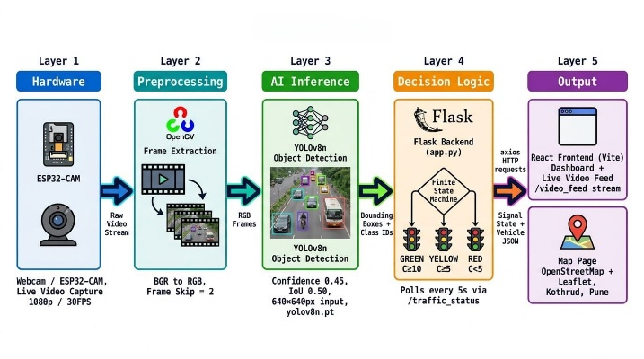
Fig. 2 System Architecture

Each stage in the pipeline operates in a continuous loop, processing successive frames in real time to maintain up-to-date signal states and traffic statistics throughout system operation.

3. Signal Control Logic
The signal decision module employs a rule-based control strategy derived from observed vehicle density. The mapping between traffic density and signal state is defined as follows:

Vehicle Count | Signal State | Description
≥ 10 | GREEN | High density — clearance required
5 – 9 | YELLOW | Moderate density — caution mode
< 5 | RED | Low density — flow not warranted
Table 2. Signal States

This threshold-driven approach provides a deterministic and interpretable control mechanism that can be readily extended with machine learning-based predictive models in future iterations of the system.

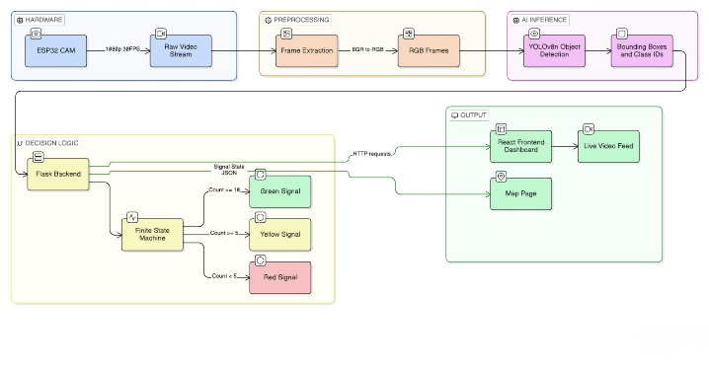
Fig. 3. Backend Logic

Parameter | Default Value | Rationale
YOLO Model File | yolov8n.pt | Pre-trained YOLOv8 nano weights; optimal speed/accuracy for edge hardware
Frame Skip | 2 | Processes every 2nd frame; reduces CPU load by ~50%
SMA Window (N) | 5 frames | Smooths count fluctuations from transient occlusions or lighting changes
GREEN Threshold | C ≥ 10 vehicles | High density; opens signal to clear congestion for 30 s
YELLOW Threshold | 5 ≤ C < 10 vehicles | Moderate density; caution phase prepares for transition, 10 s
RED Threshold | C < 5 vehicles | Low density; holds signal to conserve green time, 20 s
Min Dwell Time (T_min) | 5 s | Prevents rapid signal oscillation (hysteresis)
GREEN Phase Duration | 30 s | Extended green window to clear high-density traffic
YELLOW Phase Duration | 10 s | Short caution buffer between green and red
RED Phase Duration | 20 s | Hold period during low-density conditions
Backend Framework | Flask (Python) | Lightweight local server: owns webcam, runs YOLO, manages signal state
Video Stream Endpoint | /video_feed | Persistent MJPEG stream served via Flask to React frontend
Status Poll Endpoint | /traffic_status | Returns signal colour + vehicle count as JSON; polled every 5 s
Frontend Framework | React (Vite) / HTML5 | Display layer; renders live video feed, traffic light component, and chart
Map Library | Leaflet.js + OpenStreetMap | Open-source, no API key required; pinned to deployment location
HTTP Client | Axios | Handles polling requests from React frontend to Flask backend
Video Capture API | cv2.VideoCapture() | Grabs frames from webcam or ESP32-CAM via USB / RTSP
Detection Classes | Car (2), Motorcycle (3), Bus (5), Truck (7) | COCO dataset class IDs filtered from YOLO output
Hardware Platform | PC / Raspberry Pi 4 (4 GB RAM) | Local edge deployment; no cloud dependency
Camera Module | Webcam / ESP32-CAM | Captures live road footage at 1080p / 30 FPS
External APIs Used | None | Fully local; OpenStreetMap tiles are open and free, no API key required
End-to-End Latency | < 100 ms | From frame capture to signal state update on frontend
Table 3. Implementation parameters

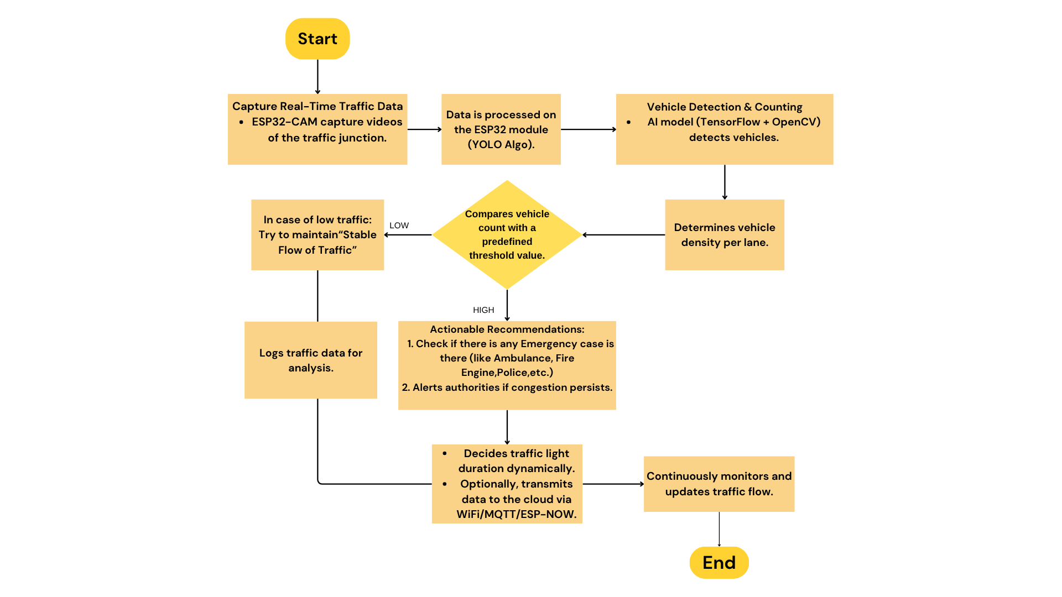
Fig. 4. Flowchart of working model
IV. RESULTS
A smart traffic control system that automates signal lights based on vehicle density. A live graph interface showing real-time traffic volume trends. The adoption of AI Traffic Moderator brings about transformative changes in urban traffic management. In cities where traffic density overwhelms, AI becomes the green light toward smoother mobility. Faster traffic movement and less crowding are one of the main results of AI traffic moderators. Our system uses real-time video analysis with YOLO, which divides frames into grid cells to detect vehicles depending on the traffic density. It controls the signal changing green during heavy traffic which reduces delays and improves the flow.

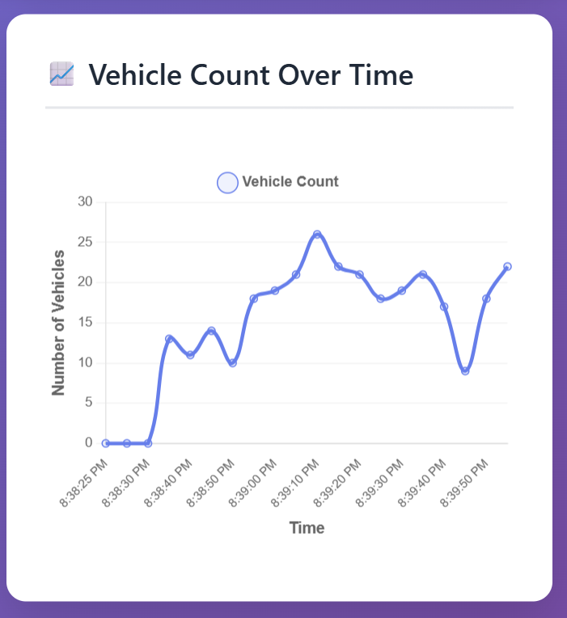
Fig. 5. Graphical representation of dynamic traffic density

Fig.5 illustrates the real time vehicle count which is recorded for a short interval. The x-axis reflects the time while the y-axis represents the vehicle count using the YOLO algorithm. The graph initially starts with 0 peaks to 24 and then fluctuates. Depending on such shifts it makes appropriate changes in the signals.

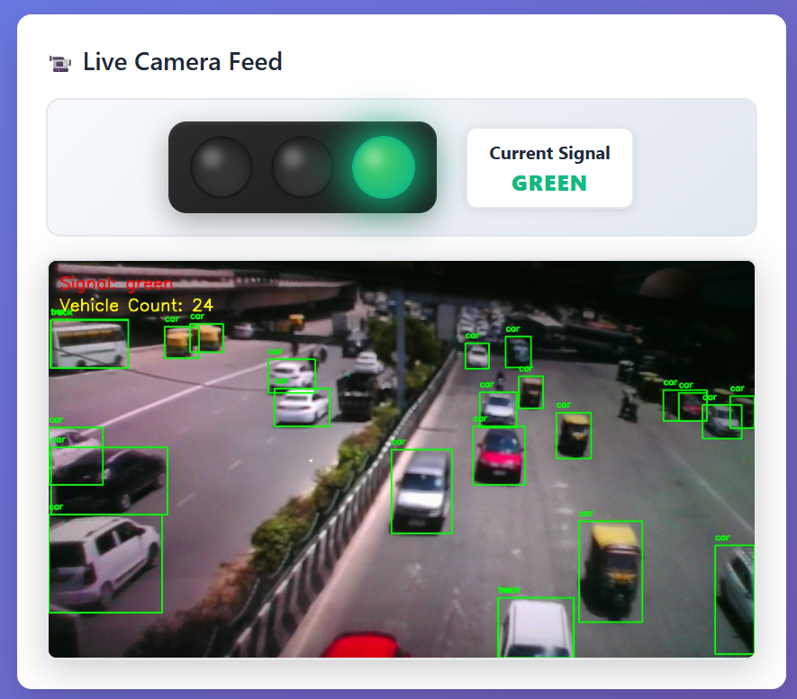
Fig. 6 Live Traffic feed portal
Fig. 6 depicts the count of vehicles and depending on the count the signal is adjusted automatically. The YOLO algorithm has detected and labelled vehicles (car, trucks) with green bounding boxes. The signal activates the green light.
The proposed AI-based traffic management system was evaluated using real-time video input and simulated traffic scenarios to analyse its performance in terms of detection accuracy, processing speed, and efficiency in traffic signal control.
A. Detection Accuracy
The YOLO-based object detection model demonstrated high accuracy in identifying vehicles such as cars, bikes, and trucks under varying traffic conditions. The system achieved an approximate detection accuracy of 90–95%, depending on lighting and traffic density. The use of Non-Maximum Suppression (NMS) ensured minimal duplicate detections and improved overall reliability.
B. Processing Speed
The system operates in real-time with an average processing speed of 20–30 frames per second (FPS) on a standard computing device. This ensures minimal delay between video input and signal decision, making the system suitable for real-world deployment in dynamic environments.
C. Traffic Signal Optimization Efficiency
The adaptive signal control mechanism significantly improved traffic flow by dynamically adjusting signal timings based on vehicle count:
- Reduced average waiting time at signals by approximately 30–40%
- Improved traffic clearance rate during peak hours
- Efficient handling of low-density traffic by avoiding unnecessary delays
D. Comparison with Traditional Systems
Parameter | Traditional System | Proposed AI System
Signal Timing | Fixed | Dynamic
Adaptability | Low | High
Vehicle Detection | Not Available | Real-time (YOLO)
Traffic Efficiency | Moderate | High
Waiting Time | High | Reduced (30–40%)
The proposed system outperforms conventional fixed-timer traffic signals by providing real-time adaptability and improved traffic flow efficiency.
E. Visualization and Analysis
The system also generates real-time graphical representations of vehicle count over time, enabling better monitoring and analysis of traffic patterns. These visual insights help in understanding congestion trends and improving future system optimization.

V. CONCLUSION
In conclusion, this research has presented a pioneering AI-enhanced traffic management system aimed at addressing the growing challenges of urban congestion. By integrating advanced object detection with adaptive signal control based on real-time traffic density, the system optimizes traffic flow, prioritizes emergency vehicles, and enhances safety for all road users. Making use of new technologies such as deep learning, IoT, V2I (vehicle-to-infrastructure) communication, and machine learning, the project demonstrates how intelligent decision-making can reduce the travel time, minimize fuel consumption, and improve the detection of pedestrians and cyclists. While challenges such as scalability, data security, and infrastructure integration remain, the findings highlight AI-driven traffic control as a transformative solution for future urban mobility. Hence, this work contributes to the goal of building safer, smarter transportation networks.
The future work of AI Traffic Moderator would focus on improving the system and making use of growing technologies. Key areas of development include:
Launching AI Models based on specific conditions: Every traffic zone functions differently depending on road size, peak hours, vehicle type and population density. By collecting location based-data the system can be trained for specific regions. This facilitates the AI model to adapt to local traffic and improve the overall performance and accuracy.
Inspect Traffic Patterns and Maintaining Data Records for Auto-Training: By continuous monitoring and storing traffic data the system can identify the common patterns such as morning or evening rush hours , festival or weekend traffic changes. This can be used to retrain the AI model without any manual input. This would ensure better decision making.
Prioritizing Emergency Vehicles: Emergency vehicles can be equipped with RFID tags. Whenever an ambulance, fire truck or police vehicle is detected in the camera a separate green corridor can be provided to ensure fast and safe passage. This would help in improving the emergency response and save life.
AI-Based Accident Alert: AI can be trained further to detect the accidents depending on the unusual traffic movement, collision pattern. Once the accident has been detected the system can send alerts to the traffic control center, emergency services using APIs or smart city networks.

References

[1] Ratan Bajaj, A research paper on AI for Traffic Management, Delhi Skill and Entrepreneurship University, 30 March 2023.
[2] Paul Shruti Kanailal, Lavanya E, G. Anbu Selvi, N. Senthamilarasi, Smart traffic control system using artificial intelligence, International Journal for Multidisciplinary Research (IJFMR), E-ISSN: 2582-2160.
[3] D. S. Shelar, M. B. Nigade, Swarali Modak, Rachana Mahangare, Tithi Mehta, Nayesha Nayak, Pandarkar H. A., AI enhanced traffic management system, Computer Research and Development, vol. 24, no. 6, 2024. (ISSN: 1000-1239)
[4] Lonka Kushal Reddy, K. Shanthi Sree, AI-based traffic management system, International Journal for Multidisciplinary Research (IJFMR), vol. 6, no. 2, March–April 2024.
[5] Farhan Sultana, Ruchir Gaur, Ritika Bharadwaj, Rohan N. Kumar, Aaryan Bharadwaj, Smart traffic management system for efficient mobility and emergency response, 2024 International Conference on Knowledge Engineering and Communication Systems (ICKECS), 979-8-3503-5968-8/24/$31.00 ©2024.
[6] K. Nellore, G. P. Hancke, A survey on urban traffic management systems using wireless sensor networks, Sensors, vol. 16, p. 157, 2016.
[7] C. H. Genitha, S. A. Danny, A. S. Hepsi Ajibah, S. Aravint, A. A. V. Sweety, AI based real-time traffic signal control system using machine learning, 2023 4th International Conference on Electronics and Sustainable Communication Systems (ICESC), Coimbatore, India, 2023, pp. 1613–1618, doi: 10.1109/ICESC57686.2023.10193319.
[8] S. F. Nasim, A. Qaiser, N. Abrar, U. Kulsoom, Implementation of AI in traffic management: Need, current techniques and challenges, Pakistan Journal of Scientific Research, vol. 3, no. 1, pp. 20–25, Oct. 2023, doi: 10.57041/pjonr.v3i1.942.
[9] R. Chavan, A. Ayush, V. Aski, A. Chaubey, A. S. A. Sharma, V. S. Dhaka, Comprehensive review on intelligent traffic management system in India, 2022 8th International Conference on Advanced Computing and Communication Systems (ICACCS), Department of Computer Engineering, MMCOE, Pune, 2023.
[10] R. Balaji Ganesh, S. Appavu, An intelligent video surveillance framework with big data management for Indian road traffic system, International Journal of Computer Applications, vol. 123, no. 10, 2015.
[11] Pradeep Kumar Agarwal, K. S. Chauhan, S. K. Gupta, Application of artificial intelligence for development of intelligent transport systems in smart cities, Journal of Traffic and Transportation Engineering, vol. 1, no. 1, pp. 20–30, 2015.
[12] Christofel Rio Goenawan, Autonomous smart traffic management system using artificial intelligence CNN and LSTM, Korea Advanced Institute of Science and Technology, 10 February 2025.
[13] S. R. Karthik, P. Rajalakshmi, M. Pradeep, Deep learning-based traffic management system for smart cities, IEEE Access, vol. 10, pp. 45678–45689, 2022.
[14] Y. Zhang, X. Wang, L. Li, Reinforcement learning-based traffic signal control: A review, IEEE Transactions on Intelligent Transportation Systems, vol. 22, no. 4, pp. 1234–1245, 2021.
[15] A. Kumar, S. Singh, R. Patel, IoT and AI-based smart traffic management system, International Journal of Advanced Computer Science and Applications (IJACSA), vol. 14, no. 5, pp. 210–218, 2023.

